Bottom Navigation Bar

Workshop #01

Flutter Developer Bootcamp

# **Purpose**

This workshop demonstrates how to Create a Bottom Navigation Bar.

# **Problem**

Create a Flutter application with a bottom navigation bar featuring three screens: Home, Notifications, and Messages. Each screen should display relevant content and be accessible via tapping the corresponding icon in the bottom navigation bar.

**Requirements:**

* Implement a Flutter app with a bottom navigation bar.
* The bottom navigation bar should include icons for Home, Notifications, and Messages.
* The Home screen should display upon launching the app.
* Tapping each icon should navigate to the corresponding screen.
* Each screen should show relevant content.
* Use Flutter's navigation capabilities for proper screen navigation.

# **How to Solve**

1. Checkout the workshop from Git Repo:

git clone -b <user-branch> <repo-URL>

2. Open the root folder inside VS Code

3. To build the app click the run option in the main method { }

4. Create a notification screen in the bottom navigation bar and add the notification icon to the bottom navigation bar.

5. Create an AppBar with the text 'Empetz'.

**You Will Achieve**

At the end of the workshop, you'll learn about arranging widgets, controlling states with currentPageIndex, navigating with BottomNavigationBar, and following Material Design. Additionally, you'll see how to display lists, change themes using Theme.of(context), and customise the user interface.

# **Screenshots**

## **Before implementation (without Notification screen)**

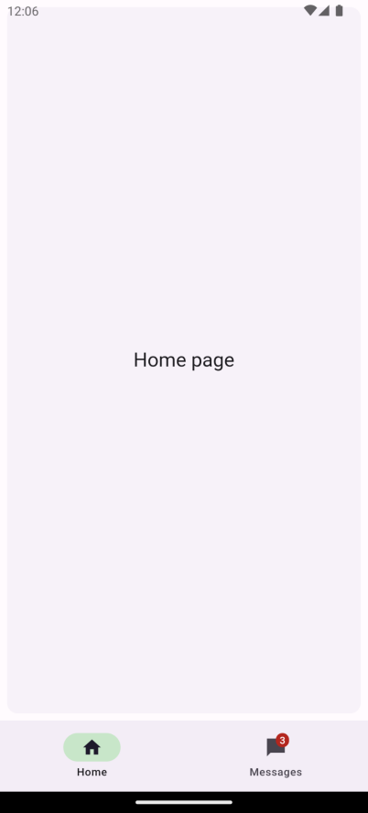 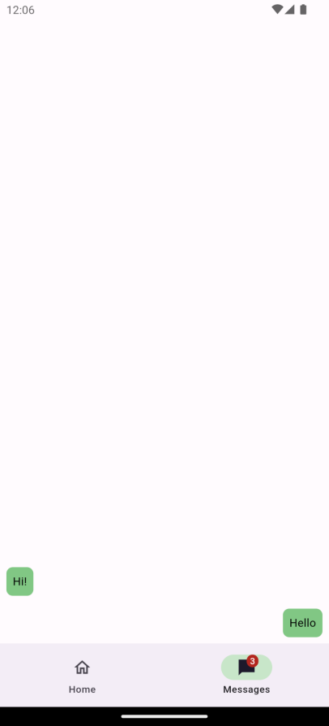

## **After implementation (With Notification screen)**

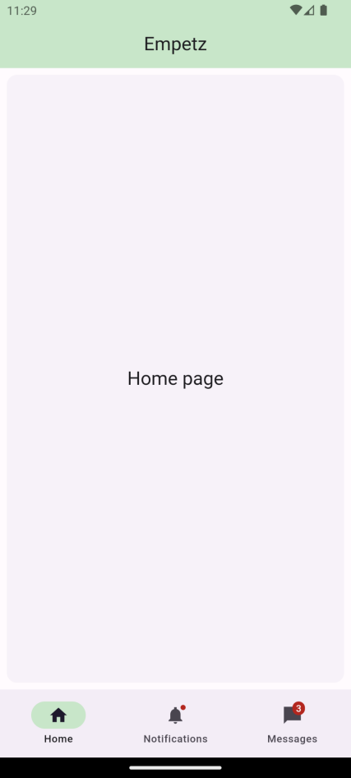 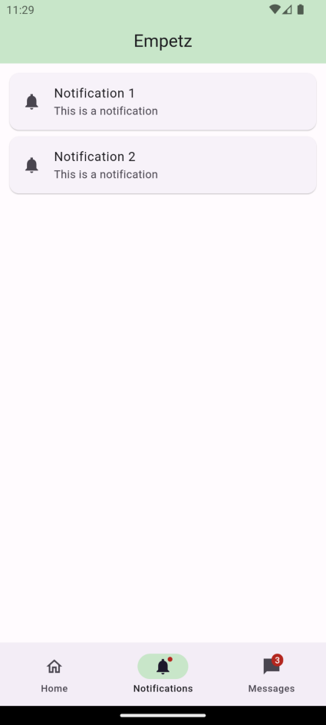 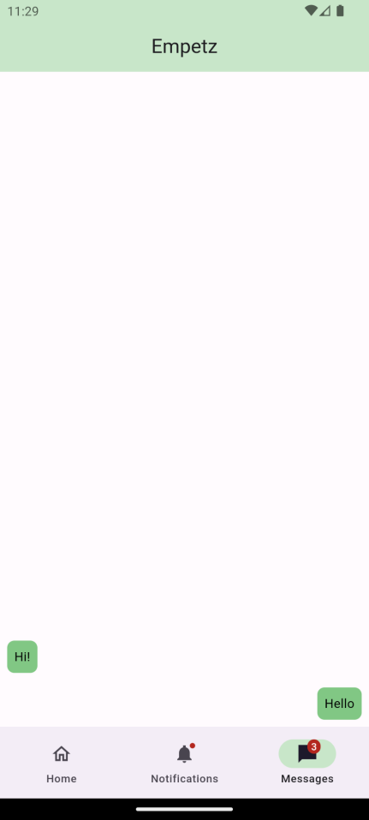

# **How to submit your workshop**

Push your project back to the same git branch using command:

<command name>

# **Happy Coding!**